Industrial caffeine-cas-58-08-2
Taj Active Pharmaceuticals Ingredients |  | www.tajapi.com
 |   Raw Material / Chemicals Index

Natural Caffeine (CAS 58-08-2) Market Research Report 2010
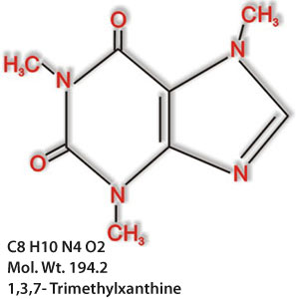
The study ‘Natural Caffeine (CAS 58-08-2) Market Research Report 2010’ presents an overview of the Natural Caffeine market globally and regionally by contemplating and analyzing its parameters.
Key features of the report:
- provides general information on Natural Caffeine
- examines applications of Natural Caffeine, its consumers
- provides an overview of the Natural Caffeine market and supplies a list of Natural Caffeine manufacturers and suppliers worldwide
- considers Natural Caffeine current market prices
The research is based on reliable data and supplies the latest information on selected aspects of the market.
Pharmacokinetic data
Bioavailability 60–80%
Metabolism Hepatic (CYP2C9)
Half life 11–15 hours
Excretion Renal 20%, faecal 65%

1. GENERAL NATURAL CAFFEINE DESCRIPTION, COMPOSITION, INFORMATION ON INGREDIENTS, HAZARDS IDENTIFICATION, HANDLING AND STORAGE, TOXICOLOGICAL AND ECOLOGICAL INFORMATION, TRANSPORT INFORMATION
2. NATURAL CAFFEINE APPLICATION AREAS, PATENTS
3. NATURAL CAFFEINE MARKET. MANUFACTURERS AND TRADERS OF NATURAL CAFFEINE (INCLUDING CONTACT DETAILS)
3.1. Manufacturers of Natural Caffeine
- Europe
- Asia
- North America
- Latin America
3.2. Suppliers (trading companies) of Natural Caffeine (including contact details)
- Europe
- Asia
- North America
4. CURRENT NATURAL CAFFEINE MARKET PRICES
- European market
- Asian market
- North American market
5. NATURAL CAFFEINE CONSUMERS
- Europe
- Asia
- North America
- Latin America
- Africa
- Oceania .

